**Smart Water Management Using IoT: Real-World Examples**

It’s easier to understand climate change when you experience challenges yourself. Consider unpredictable water supply, worsening water scarcity, and water pollution. Whether you’re an agricultural firm or city administration, all these affect you. And if you’re looking to become more efficient and boost your green credentials, you might not know where to turn.

This is where smart water management using IoT could make all the difference.

Among the many benefits of IoT technology, it helps keep water quality high. Smart sensors can provide peace of mind that equipment like pumps and pipelines is highly functional, and with IoT services, you can dispose of wastewater safely and in line with regulations.

Let's take a closer look at the most common real-world examples that illustrate the impressive advantages of smart water management systems.

**Smart City Water Management**

City administrators need to keep a close eye on water supply, consumption, and equipment. With IoT, the whole water supply chain can become more transparent and easier to control.

With the help of sensors, a smart city water management system can enable you to collect real-time data—information that helps you visualize water distribution across the network. Residents with smart meters can make more informed decisions as a result, leading to a more sustainable city overall.

Water waste and disrupted water supply chains are a drain on the city’s budget. IoT can help you watch the health of water equipment and detect problems, like leaks in pipes. This allows operators to receive alerts and start fixing issues immediately. In the meantime, AI predictions allow you to nip problems in the bud by preventing failures before they cause severe incidents. With AI, city administrators can also watch the watershed and predict which areas are likely to flood, information that will help local authorities warn residents, manage traffic, and keep the city on its feet.

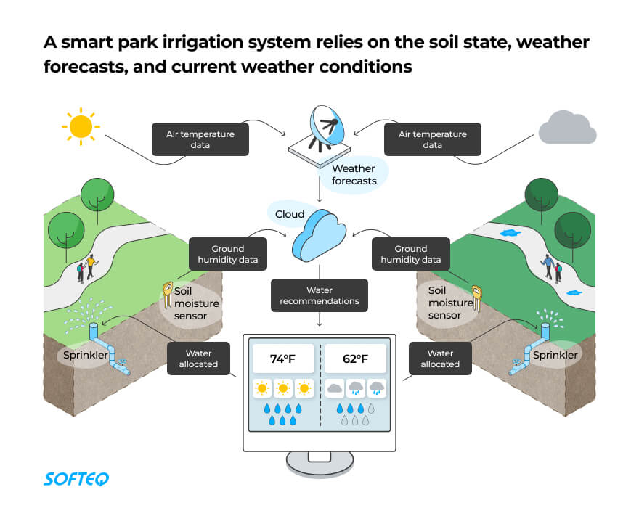smart water management

**Real-World Example: Smart Irrigation of City Parks**

Cartagena, a city in Columbia, has smart irrigation in its municipal parks and gardens. The solution calculates the amount of water each area needs depending on the state of the soil, weather forecast, and irrigation calendar. If something goes wrong, such as a leak, the authorities are alerted right away and they’re even shown the location.

**Main benefits**

* Better transparency in water management
* Fewer incidents
* Enhanced control over the water supply
* Saved city budget
* Improved city sustainability

**Water Quality Management System**

Watching the quality of water that comes into our houses is crucial. Rivers, lakes, and reservoirs may contain contaminants that are dangerous to us, and the increasing world population combined with urbanization has also worsened water quality. In our changing world, IoT can help monitor and analyze distributed water and ensure it complies with regulatory standards.

A water quality management system using IoT can deal with quality issues effectively. You only need to consider a simple comparison to appreciate the difference: Without IoT, water samples need to be collected and analyzed manually. This process is costly and time-consuming because it requires large equipment and an expensive workforce. In contrast, IoT sensors can measure a variety of parameters like temperature and turbidity. Operators receive regular data from multiple samples, enabling them to remotely perform quality control on water reserves.

**Real-Life Example: Watching the Quality of River Water**

A solution from Ericsson and AT&T monitors water quality for the city of Atlanta, Georgia, where four million citizens get drinking water from the Chattahoochee River. IoT helps authorities check the quality of water, while sensors measure its conductivity, turbidity, temperature, and thermometry.

**Main benefits**

* Increased water quality
* Saved budget on manual analysis of water samples
* Smaller workforce involved
* Remote quality control
* Compliance with regulatory requirements

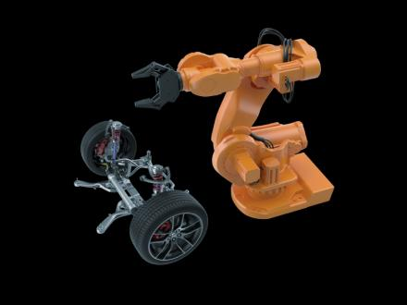

**Water Level Monitoring and Dam Management**

Dams bring water to livestock and irrigation and supply many industries. They also play a pivotal role in flood control and can assist river navigation, so it’s crucial that dams and reservoirs function properly and their water levels are safe. The trouble is that traditional monitoring methods are time-consuming and complex.

Water level monitoring and management of dams using IoT can improve this, using ultrasonic, vibration, and pressure sensors to help monitor dam function. With pressure sensors, in particular, you can detect leaks in pipes and receive instant alerts. Predictive technologies ensure dam operators get early warnings and are able to keep watch over water availability in each reservoir. This may be particularly helpful for irrigation.

A smart solution can also give you remote control over the movement of gates, so there’s no need to send staff to the site in severe weather conditions like floods or storms. If the water reaches a certain level, the system can decide to open or close the gate.

**Real-Life Example: Smart Dam Monitoring**

A ThingsLog level monitoring solution helps dam owners in Bulgaria to manage more than 100 dams in the region. IoT sensors remotely watch water levels at each dam site. The system sends instant alerts if flooding is possible. With smart capabilities, there’s no need to send staff to measure water levels on site. The system even has pre-programmed formulas that replace manual calculations

**Main benefits**

* Real-time water level monitoring
* Better dam functionality
* Enhanced dam reliability
* Faster decision-making
* Saved time and resources
* No human involvement

**Smart Water Management for Agriculture**

The world population has exploded in recent decades, and more people mean more food. But that’s not the only thing that’s new. Food consumption patterns have also changed, leading to increased global crop production that requires savvy water usage. Water scarcity can negatively affect yields as much as water oversupply. IoT is helping to make this process more efficient and smart than ever before.

A smart water management system for agriculture using IoT can improve crop fields providing farmers with the oversight they need to avoid water waste. Sensors monitor multiple parameters, like temperature, humidity, and soil moisture to calculate how much water crops need. These sensors are connected to the field and sprinkler in sprinkler irrigation systems, and farmers receive regular updates on their smartphones.

With AI on board, you can plan agricultural activities wisely and in advance. Crop water management using IoT helps farmers use less water to grow the same amount of crops. The technology also enables them to use less fertilizer, save energy on pumping less water, and save time and money on labor. IoT solutions also make it possible to see the water level in tanks.

Newsletter

**Real-Life Example: Smart Irrigation Management**

The Galileo System from Galcon aids and optimizes irrigation in open farmlands and greenhouses. An open-field version has about 200 irrigation programs. Farmers can watch up to 50 main irrigation lines, change flow intensity, and schedule their activities. What’s more, the software shows a realistic picture of the watered field.

**Main benefits**

* Boosted productivity of agricultural activities
* Better quality of products
* Prevented water waste
* More efficient use of water, fertilizer, and energy
* Automated activities
* Optimized farm labor

**Perspectives**

With such expansive and varied use cases, the potential of smart water technologies is clear to see. We also have optimistic estimates on the global smart water management market value which is developing rapidly. 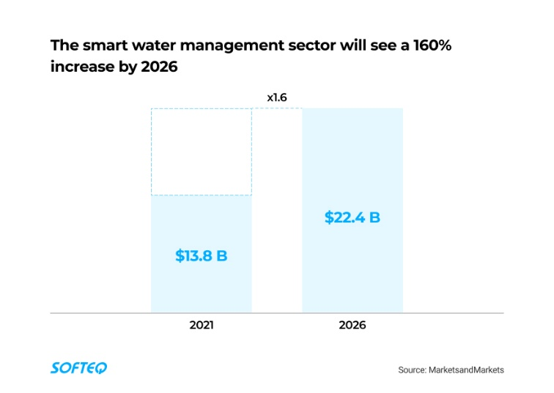

The global smart water management market

Some of the key factors driving this market include new laws and regulations on reduced water consumption that aim to meet sustainability objectives. Water-related standards, in particular, ensure local authorities and water suppliers provide safe and high-quality water. For example, the Safe Drinking Water Act sets the standards for drinking water quality in the US. IoT technology will help companies comply with this and many other regulations while achieving sustainability goals.

**Afterword**

IoT smart water management brings transparency and optimized control to the whole water supply chain, helping industries and cities use healthy water efficiently and follow regulations. With IoT capabilities, you can even collect and recycle wastewater.

If you need a trusted consultant to assist you in optimizing water production, distribution, and consumption, Softeq is here to help. We have unrivaled expertise in hardware design, software, and embedded system developments, all under one roof.